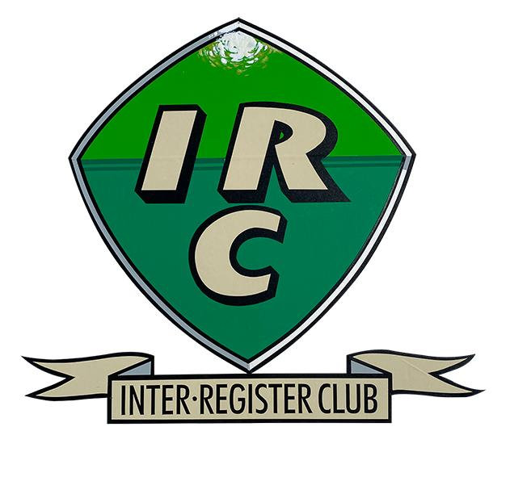 | 

Table Top Rally
3rd November 2024 –Regulations and Entry Form
This event is being hosted by Philip and Rosemary Bayne-Powell on behalf of the Inter Register Club and the MG Car Club. This event will take place in the comfort of your home, with no fee charged.
You will need the OS Landranger 1:50,000 Map186 –Aldershot and Guildford February 2016 edition (with new legend); available from dash4it.co.uk
Navigation techniques will be used such as spot heights, grid references, coloured roads etc. Not all routes will be on public roads. Answers to the questions will be found on the map at the end of each section, proving that you have correctly arrived at the finish.
There will be 15 sections with increasing scores, starting with the easier clues and getting harder with ensuing sections. If you get stuck on one section, move onto the next section, so as to get the most results, and hence a maximum score.
Please confirm you wish to partake in this event by e-mailing your entry form to 1942mgman@gmail.com before Sunday 3rd November 2024. Please state your virtual vehicle, so IRC points can be awarded. Also state the class that you are entering from the choice below.
Class A – Expert Competitors who have finished in the top five of any navigation scatter event or 12-car rally, or the top ten of a National B Rally, in the last 5 years.
Class B – Novice Competitors with more limited navigation experience.
As before, the instructions and questions will be sent to all novices by e-mail at 10.00am and the more difficult instructions to all experts by e-mail at 10.30am. You will then have 2 hours (Experts) and 2¹/₂ hours (Novices) to complete the event by submitting your answers to the clues by e-mail them to the organisers by 12.30. Late finishers incur a penalty of one point for every minute late.

Results will be distributed by e-mail as soon as possible on the following day, depending on the size of the entry..
If any further information or details are required, please e-mail Philip on 1942mgman@gmail.com or phone 01483 811428.

Table Top Rally 3rd November 2024
ENTRY FORM

Please return to Philip by e-mail (1942mgman@gmail.com)

Driver’s name ............
Navigator’s Name .....................
Virtual car details ...........
Class entered A (expert) .........
or B (novice) ...............
Entrant’s Car Club .............
Telephone Number ...... e-mail .........

