Throughout 2024, the SE Centre continued to promote some grass roots competition and competitive events. All the events were reported on both the SE Centre website and in the newsletter, but here is a brief summary of the year’s activities:
- The Valentine Treasure Hunt on 25th February was run to the area South West of Reigate in Surrey. This event was run by Epsom MGOC with an invite to MGCC SE Centre members.
- Despite planning to support the Production Car Trials organised by MMKMC, clashes of event dates resulted in no MGs being able to enter last year.
- The Spring and Autumn Naviscats were planned for 3rd March and 6th October. The Spring event was organised by Philip and Rosemary Bayne Powell and held to the south west of Dorking with 19 cars entering. Unfortunately the Autumn Naviscat had to be cancelled through insufficient entrants.
- A fully competitive event organised was held on 23rd March, namely an AutoSOLO held at Filching Manor near Polegate in East Sussex on their now closed Gokart circuit. This proved a great success with the overall entry being in excess of 40 cars including 14 MGs. Entrants from some other clubs who regularly run AutoSOLOs stated that this venue was one of the best with its undulating topography.
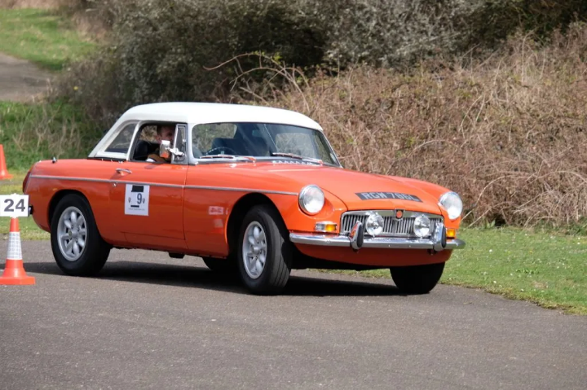 | 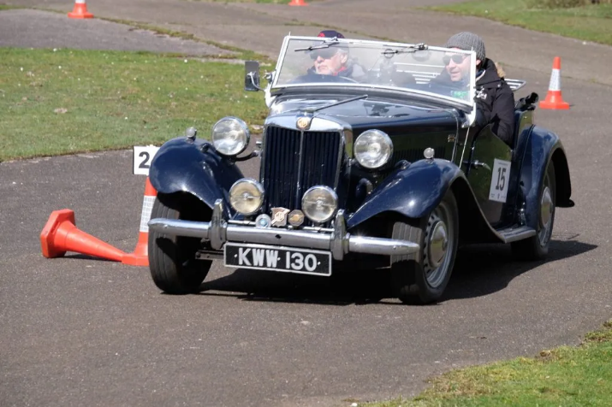
- MG100 SE weekend replaced the Spring Gathering. The event was run by multi-SE MG Clubs. Five Road Runs routed from across the SE converged on The Fairmile Pub for an afternoon and evening gathering with a buffet dinner. Brooklands on the Sunday was a major gathering with over 500 cars and 2000 people. The event included pride of Ownership, guest speakers in the Clubhouse, large display of competition cars, Pull-the-MG competition and more.
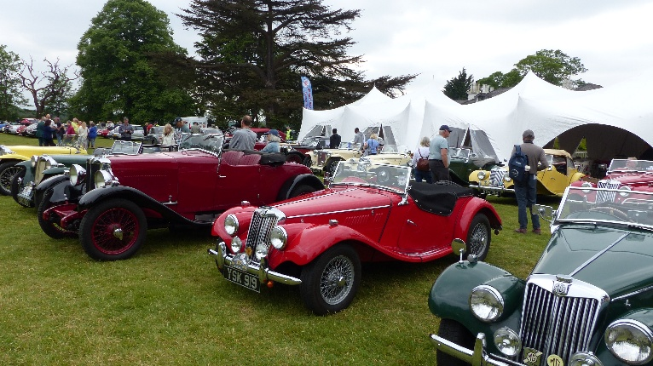 | 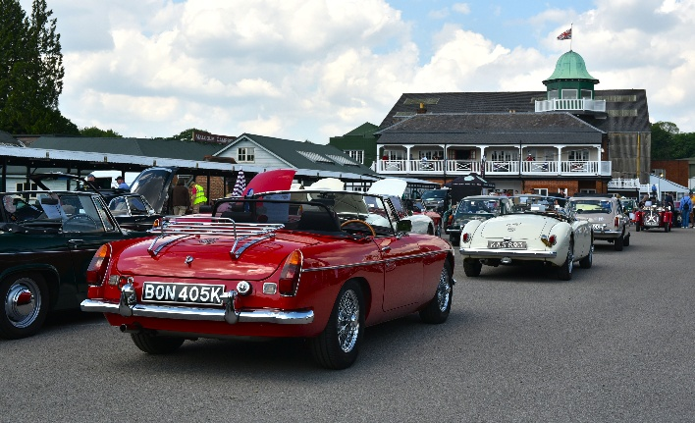
- A Summer Gathering was held at West Horsley Place between Leatherhead and Guildford and the event included a Touring Assembly, Concours and Pride of Ownership competition. The event was blessed with a pleasant summer’s day and a good turnout of MGs.
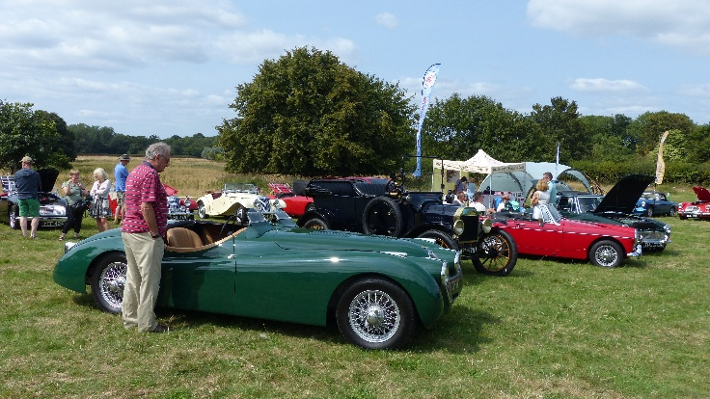 | 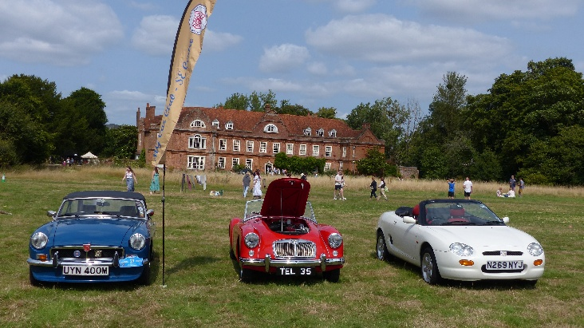
- At the end of the season, an Autumn Leaves Run with Scavenger was held on 13th October with 17 entrants, centred between around Turners Hill, West Sussex.
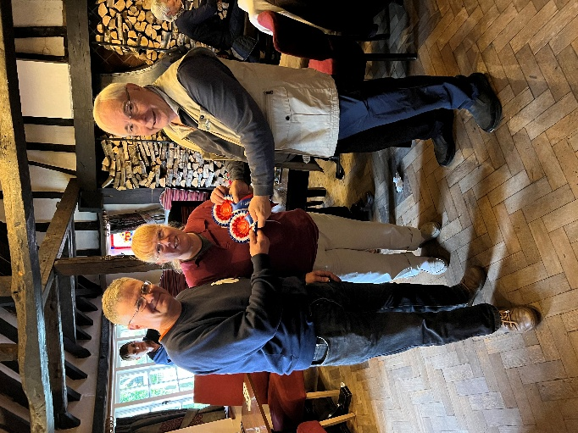 | 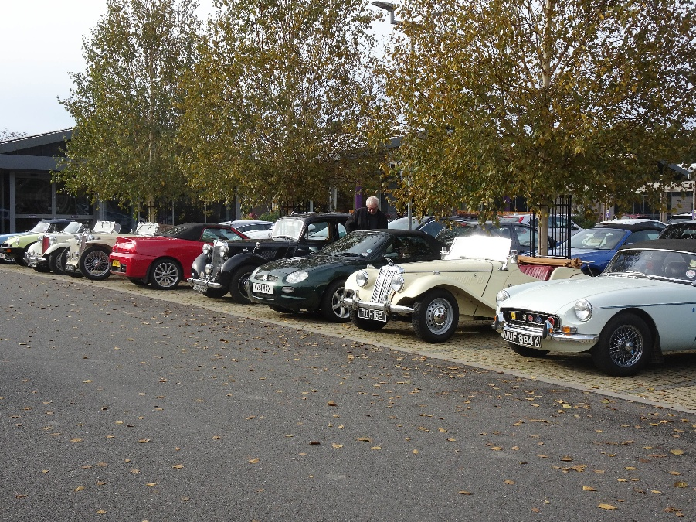
The SE Centre continued to participate with the Association of South Eastern Motor Clubs (ASEMC) and this will allow the SE Centre to receive invitations from numerous motor clubs from all over the SE region.
The SE Centre continues to support the MGCC main club working party to maintain the set of event guides to ensure compliance with the Current Motorsport UK event Regulations. These are available to all members in the member area of the MGCC website
Looking ahead to 2025 season, events will continue with the AutoSOLO, Naviscats, Road Runs, Pride of Ownership, and something new, an Evening Autotest.
If you would like any information on how to take part, what is involved, what events are being organised, or what invitations the SE Centre has received, then either email me on competitions@mgccse.co.uk or give me a call on 07802 770025.
John Morgan – Competition Secretary

